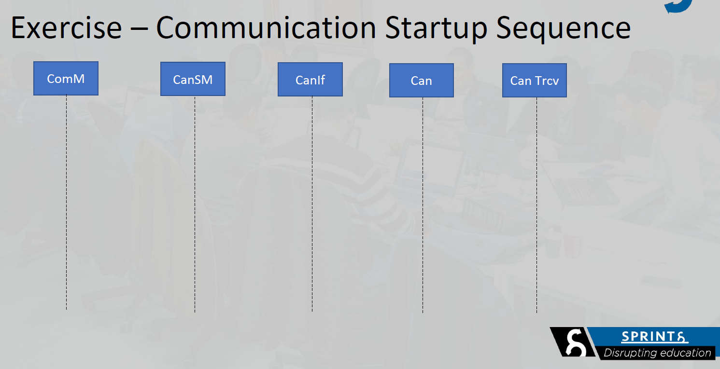

CanTrcv_SetWakeupMode

CanSM_RequestComMode

Can_SetControllerMode

CanIf_SetControllerMode